2017 Fall 200 – Lab 1

Task 1
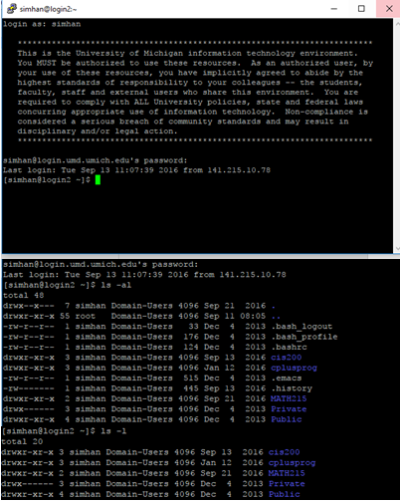
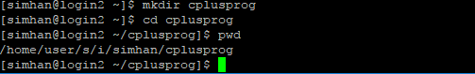
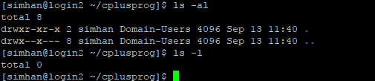
The only files that are invisible are the current directory ( . ) and the parent directory ( .. ), respectfully.
Task 1: This task was about learning to navigate through and create directories. I learned how to list all the contents of a directory in different ways, make a directory, and how to move into/out of a directory. I didn't face any problems.
Task 2
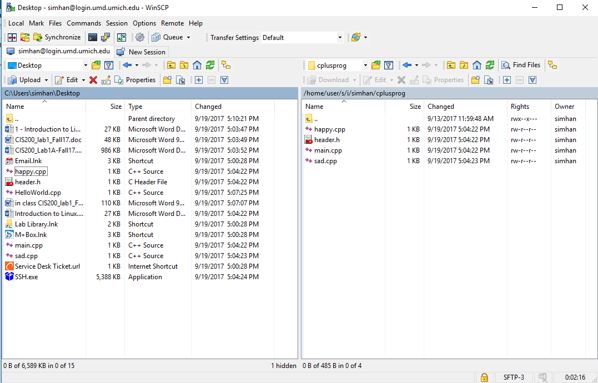
Task 2: This task was about learning how to work with SSH file transfer (using WinSCP). I learned how to transfer downloaded .cpp files and use SSH Secure File Transfer to make a copy of them and place them in a directory. I didn't face any problems.

Task 3
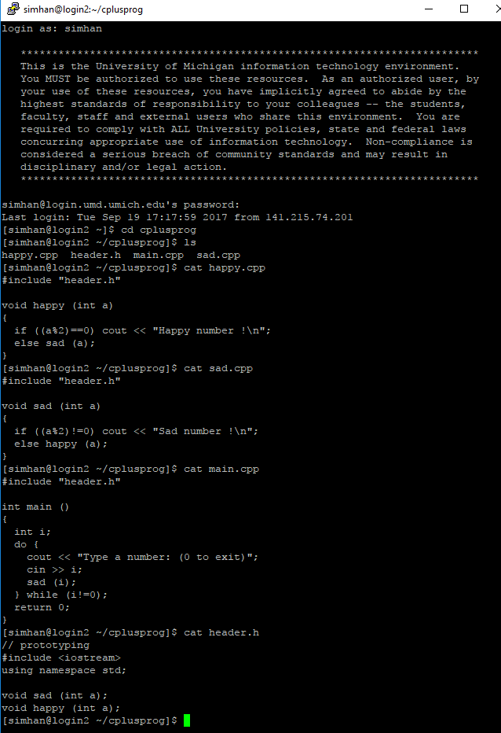

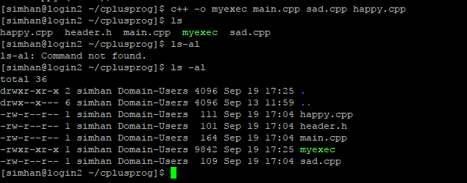
Task 3: This task was about learning to use the cat command to check the contents of the .cpp files, and to compile them. I learned how to use check the contents of the .cpp files and compile them as an executable file. I didn't face any problems.

Task 4
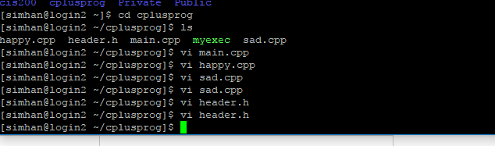
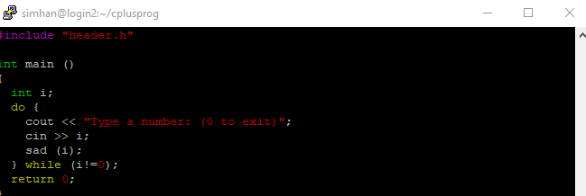
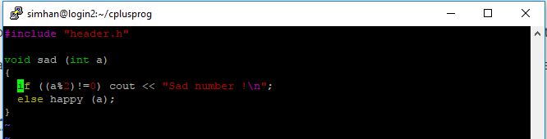
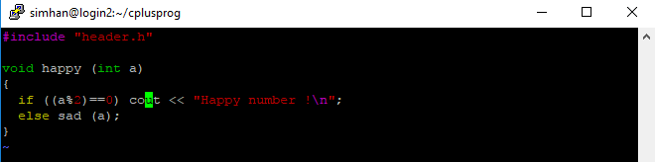
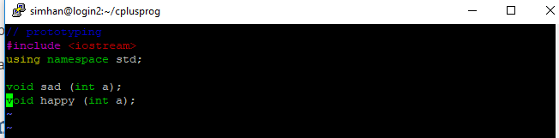

Task 4: This task was to learn how to use the vi UNIX systems text editor. I learned that there are two mode in vi: command and input modes, as well as how to properly edit with them. I didn't face any problems.

Task 5
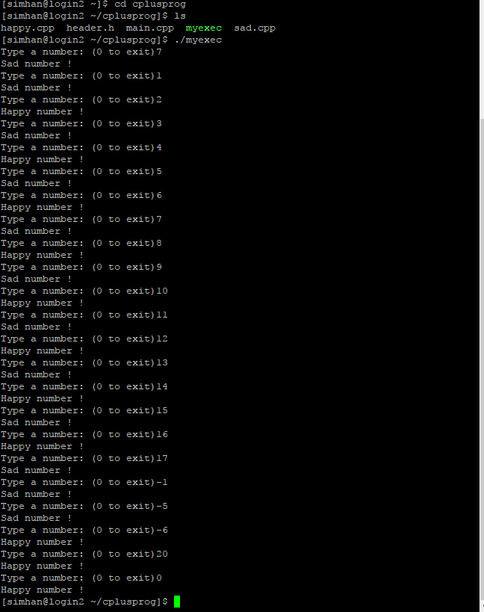

Task 5: This task was to learn how to run the executable files and have it display on the screen output. I learned hot to run the executable file using the prefix "./". I didn't face any problems.

Task 6
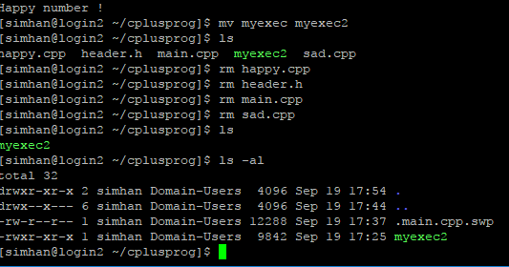
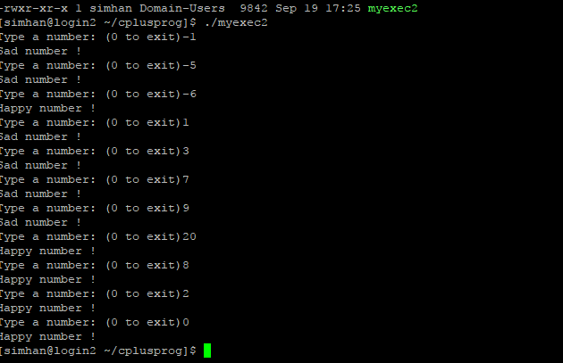
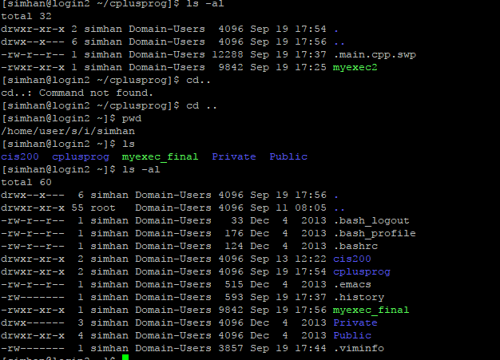
Task 6: This task was to learn how to change the executable name and use the mv command. I learned how to change the name, delete all the original files, run the executable, copy the executable files into another file, and check the contents of all the given files/directorys/executables. I didn't face any problems.

Task 7
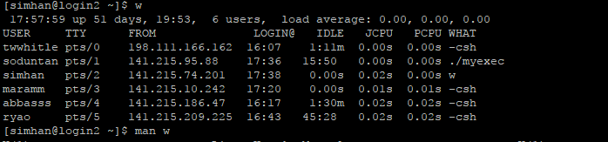
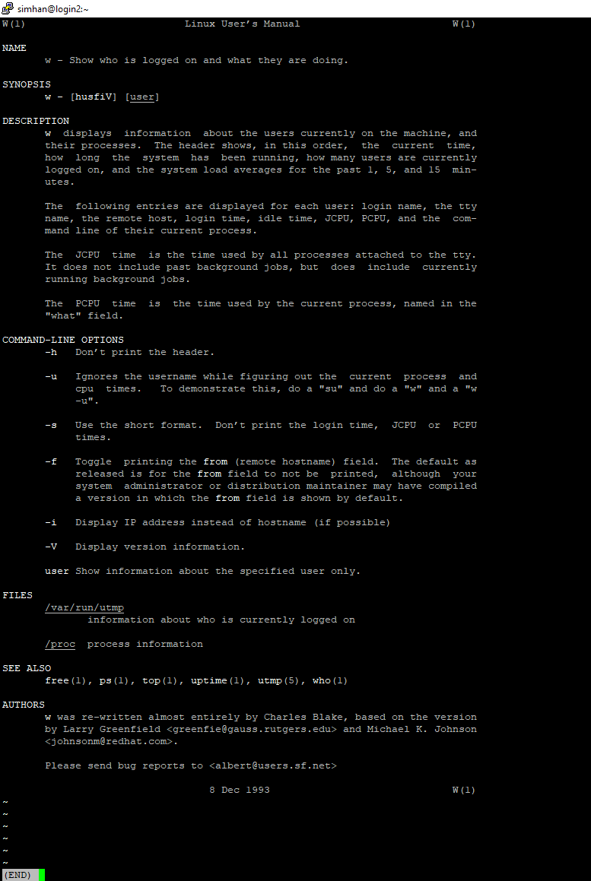
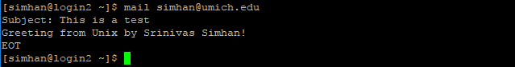

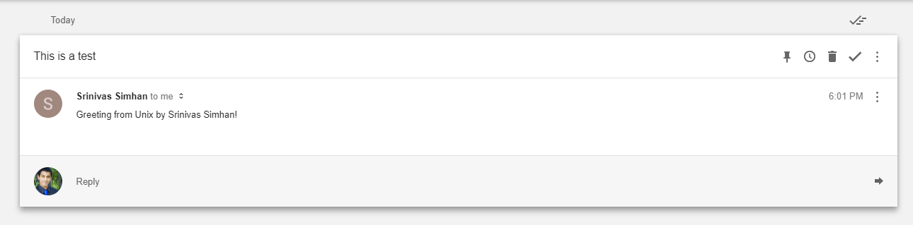

Task 7: This task was to see who logged into the system and how to send an email through UNIX. I learned how to see who logged in, how to send an email through UNIX, and how to view the instruction guide on using the UNIX emailing feature. I didn't face any problems.

